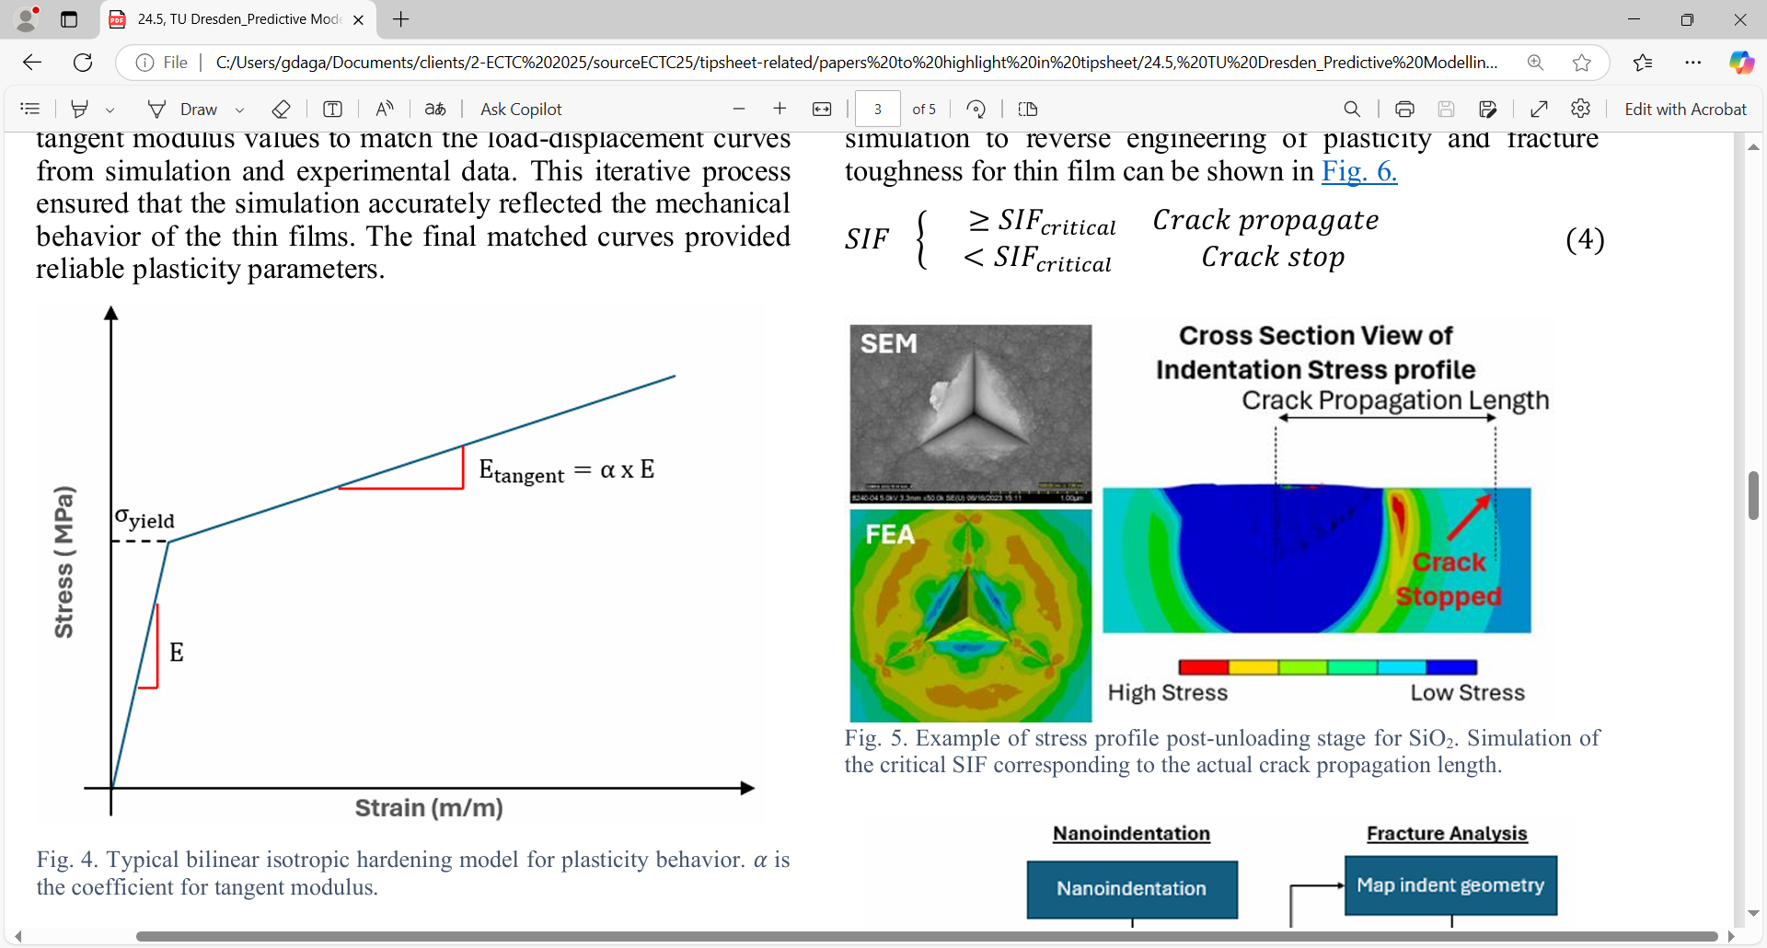

**Better Predictions of Thin-Films’ Plasticity and Fracture Behavior:** Brittle thin films such as silicon dioxide, silicon nitride and others are widely used in semiconductor devices, where their mechanical reliability is critical. It’s difficult to accurately characterize the plasticity and fracture properties of thin films at sub-micron scales, though, because of the limitations of conventional mechanical testing methods. Yet understanding these properties is essential because they directly influence film deformation and crack behavior during the manufacturing process. These, in turn, affect the performance and reliability of the microelectronics and memory devices made from these films.

At ECTC, a University of Singapore/Micron Technology team will describe a novel methodology for predicting thin-film plasticity and fracture properties by integrating finite-element analyses (FEA) simulations with experimental nanoindentation data. (Nanoindentation is where a controlled force is applied to a material's surface using a sharp indenter, and the resulting deformation is then analyzed.) The experimental results show a strong correlation between the simulations and the observed fracture behavior, validating the methodology. The researchers say this framework offers a more cohesive, easier-to-implement alternative to traditional modeling methods, and it can be extended to also predict the behavior of ductile thin films; the adhesion strength between layers; and the porosity of low-k dielectric materials, broadening is applicability.

* **The image above** compares (on the left side) an SEM view of a deliberately induced crack in an SiO2 thin film with the FEA prediction of what it would look like, showing excellent agreement. The right side of the image is an analysis of the calculated “stress intensity factor,” which corresponds to the actual crack propagation length.

**(Paper 24.5, “*Predictive Modelling of Thin Films Properties Using An Experimental and Simulation-Based Approach*,” D.K. Lim et al, Nat’l Univ. of Singapore/Micron Technology)**